In this lesson we will create some diamond like things when give us some bonus point when the ball touches it so lets get started doing that

So waht ou need to do first is to create a cube as shoen below

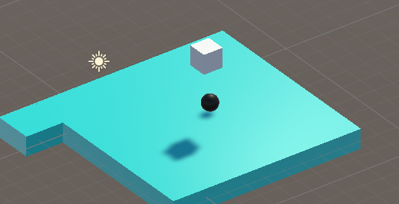
Now we rename it to Daiamon because it will look like diamond .You can name an object anything you want and make them look anything you want them to look

Now reset its position to the center if its x, y and z is zero
Now double click on it focus on it or press F
Now we modufy the cube so that it will look they way we want it to
Now we rotate the diamond named cube along x axis you can do so by choosing the rotate tool and then rotate the cube

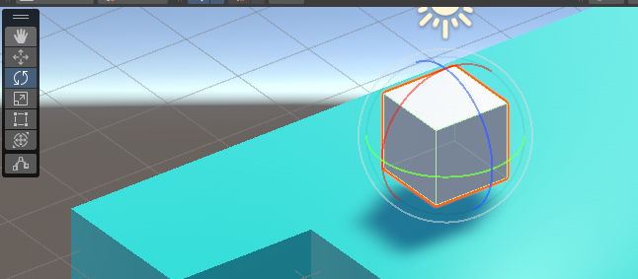
Or you can type 45 degree to the x in rotation in the inspector window

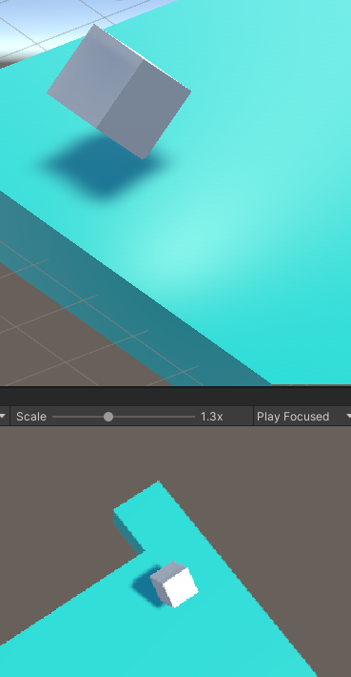
So that it will look like a diamond kind of thing So i think this should be good whenever our ball is touching it So we are gonig to leave it right there
Now we add a tag to it named as Diamond
and also add a color to it by creating a material and applying on it
and for the material pink we choose the color pink

Now below how your diamond will look we want that diamond to be created it should be placed above the platoform We drag and drop the diamond on the prefab folder to make it a prefab so we can create it whenever we want
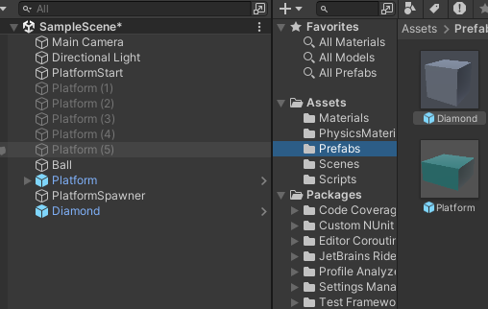
Now it will look like below

Now we delete the diamond from heirarchy panel as we can create it by prefab now
In PlatformSpawner script we have SpawnX and SpawnY function that generate the platform we will generate diamonds here

Like Platform prefab we need to create a public variable of GameObject in SpawnPlatform script and name it diamond and give it the diamond from prefab folder in unity editor

We don't want to spawn teh platoform in each and every platform So here again we will create a random number and if that number comes inside a range then we spawn the daimond otherwise not

we create a random range between 0 to 4 and store it in a local variable rand of int type
so there are only 4 number 2 for spawning and 2 for not spawning
but it is not goos since we want to reduce the chances of spawning of diamond so in condition we want that rand should be less than 1 so if the rand is equal to 0 then we want the diamond to be spawned but if they are remaining number then the diamond should not be spawned so that not spawning are more favorable

Now inside the if block we instantaite our Daimond
Now our spawnX code in spawnPlatform file will look like below

void SpawnX()
{
Vector3 pos = lastPos;
pos.x += size;
lastPos = pos;
Instantiate(platform,pos,Quaternion.identity);
int rand= Random.Range(0, 4);
if( rand < 1)
{
Instantiate(diamond,pos,Quaternion.identity);
}
}
Now we copy the above highlighted code into SpawnZ

So we create a random number and if it is equal to 0 or less than 1 then the diamond is generated or otherwise no diamond will be spawned
So not spawnign diamond has more probablity to ocur

But now the diamond is generated inside the platform

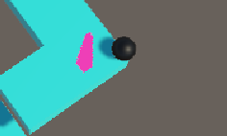

so we need to generate diamond above the platform

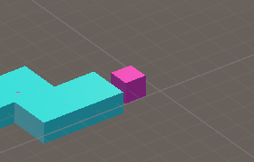
Another problem is that the diamond generated have identical rotation that is that are generated straight bit they should have been generated tilted like the diamand from which prefab have taken source of (who knows)
So we don't want the rotation of generated diamond to be zero.

So we need ot remove Quaternion.identity

Now out SpawnX and SpawnZ code will look like below

void SpawnZ()
{
Vector3 pos = lastPos;
pos.z += size;
lastPos = pos;
Instantiate(platform, pos, Quaternion.identity);
int rand = Random.Range(0, 4);
if (rand < 1)
{
Instantiate(diamond, new Vector3(pos.x, pos.y + 1, pos.z), diamond.transform.rotation);
}
}

So in above code in Instantiate we passed new position object having x and z position same as platform but y should be grater than 1 due to which it will be generated above the platform and we have replaced Quaternion.identity with diamond.transform.rotation So we can apply rotation equal to our preface diamond instead of default 0 rotation according to the global axis

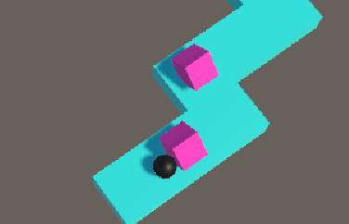
but now the problem arises is that the ball get stuck after colliding with the diamond so we set is triggered to true so that the ball does not collide with it but pass through it.

11:30
Now when the ball goess through diamond we just need to dimply destroy these diamonds
One momre thign we can do is that we can add frictionless materail to out diamond ( i don't know )
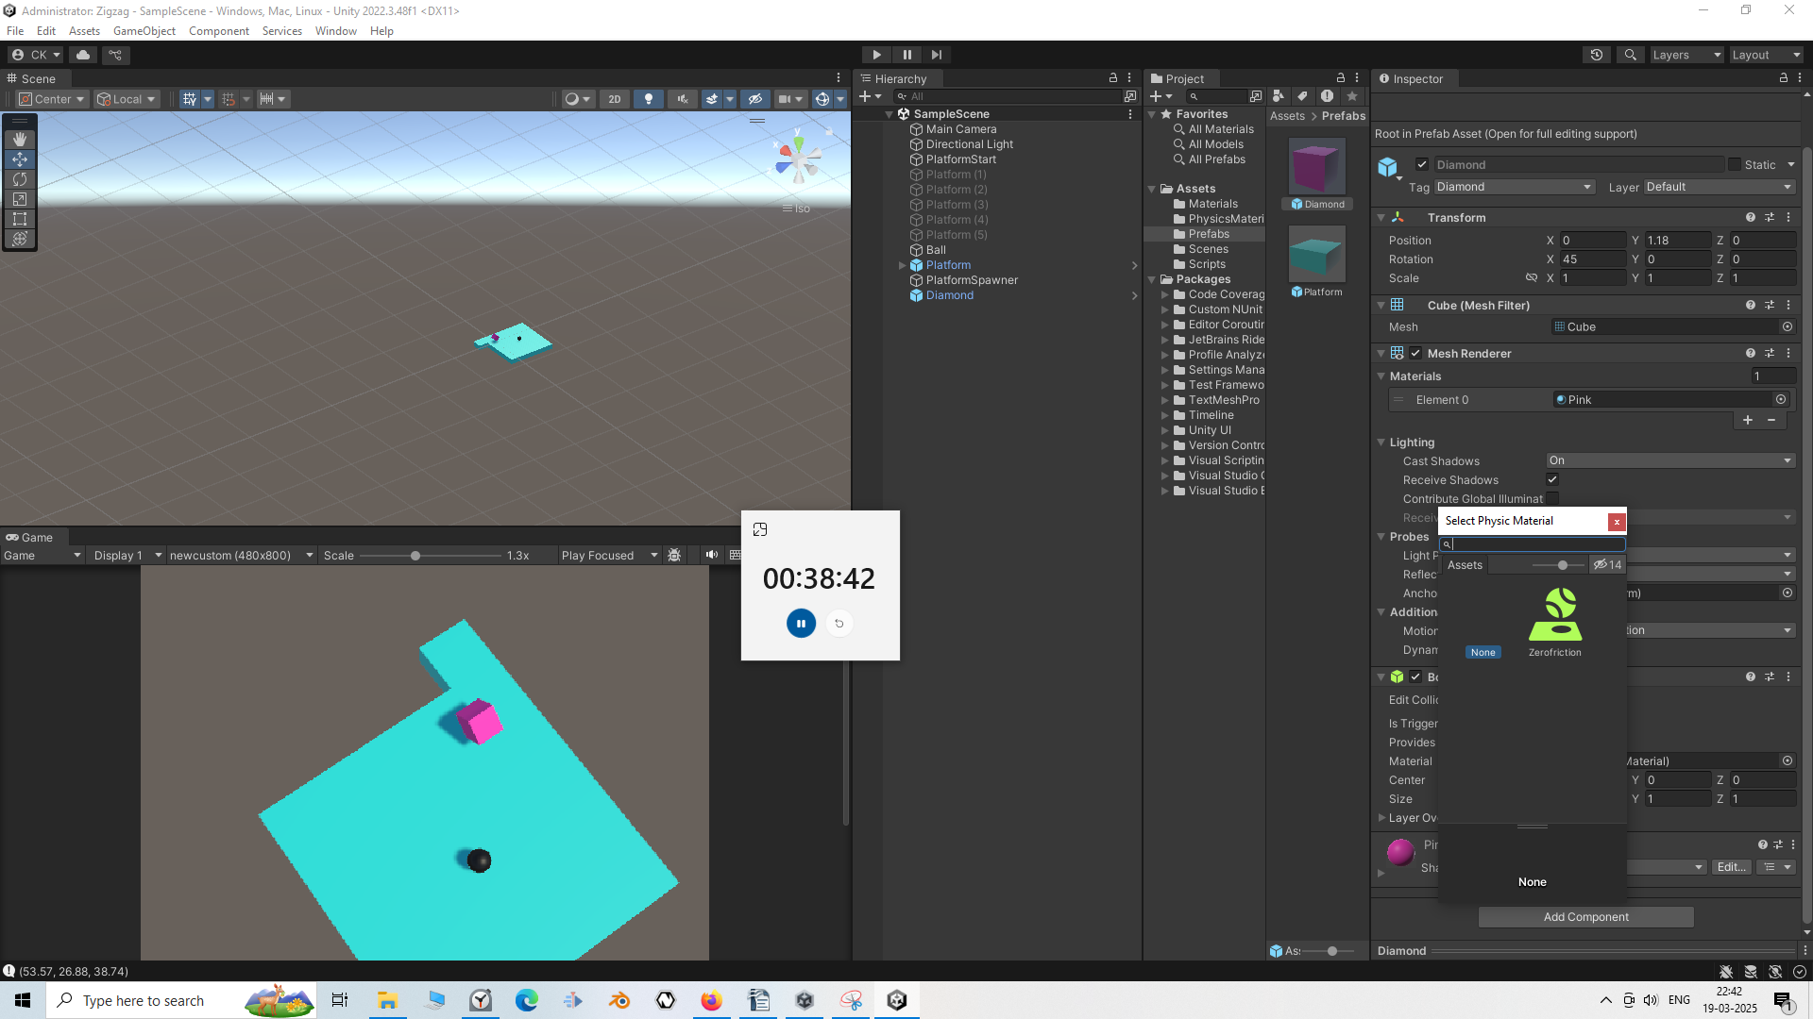
Now we clikc on dot of the material in box colldor of the daimoand Prefab and then in new window click on the xero friction so that friction will not work on the daimond and the ball (i don't know because diomand has istrigger checked )'

Now we want to destroy the diamond when they will collide with the ball

